Name:_____________________________
Study Guide for Force and Motion!
Vocabulary!
Forces: a force is a push or pull upon an object.
Newton (N): a unit of force
Friction: the resistance that one surface or object encounters when moving over another.
Electrical Force: Caused by electrical magnetic forces
Gravitational Force: the earths pull on objects
Motion: the action or process of moving or being moved.
Position (X): a place where someone or something is located
Delta ( ): change in (something)
Distance (d): the length of travel
Reference Point: something you use to determine the position of an object
Variable: able to be changed
Equation: a formula to help solve a mathematical problem
Speed (v): how fast an object is moving
Velocity (v): the speed and direction of a moving object
Slope: used to find the change in distance and time or average speed
Line Graph: a graph used to measure and compare data
Leg (of a trip): a part of a graph which represents a separate event
Displacement (of a trip): changing position
Net Force: the total force being applied
Spring Scale: a tool used to measure force
Effort: energy that is exerted
Fulcrum: the point or support about which a lever turns (lever, or a seesaw)
Load: the amount of material being applied to something
Gravity: the force earth exerts on everything on or near its surface.

Equations!
Drago Sits Tall!

Distance Equation 1:

Distance Equation 2:

Time Equation:

Speed Equation:

Velocity Equation:

Acceleration Equation:

Measuring Tools:
Tools for Measuring Distance:__________________________________________________________________________
__________________________________________________________________________________________________
Picture:

Tools for Measuring Time:____________________________________________________________________________
__________________________________________________________________________________________________
Picture:

Tools for Measuring Force:____________________________________________________________________________
__________________________________________________________________________________________________
Picture:

Sample Problems!

- Beth’s motor scooter gets 110 km/gal. How far can she go on 2.5 gal of fuel?
Cover this answer: 110km x 2.5 = 275 km
- An ostrich can run 10 km in 15 minutes. What is its speed in kilometers / hour?
Cover this answer: 10 km x 4 = 40 km/h
- Which runner is the fastest? How do you know?
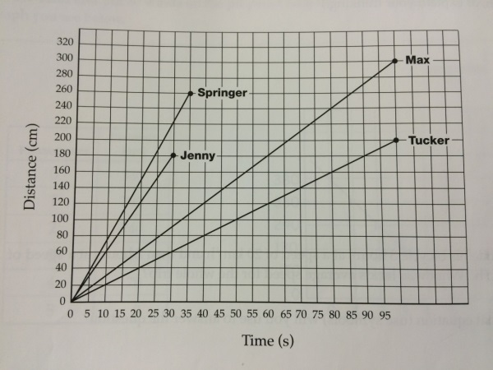
Cover this answer: Springer! This runner traveled further in a shorter amount of time. The line is steeper than the rest.
- Order these people from fastest to slowest.
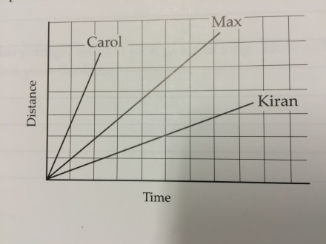
Cover this answer: Carol, Max, Kiran!
- Look at this graph. What is the average speed of the object from 0 seconds to 70 seconds? (You can use a calculator)
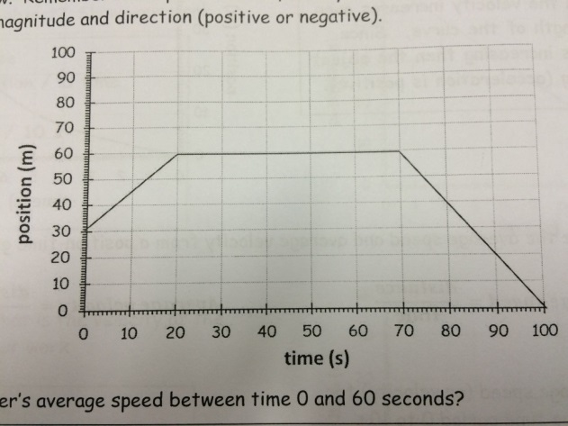
Cover this answer: Average Speed = slope = rise/run 30m/70s = 3/7 = 0.43m/s
Complete the Legs of the Story!
Create your own!
Create a Story:
Leg 1:_______________________________
____________________________________
Leg 2:_______________________________
____________________________________
Leg 3:_______________________________
____________________________________
Time
Distance
Leg 2
Leg 3
Create a Story:
Leg 1:_______________________________
____________________________________
Leg 2:_______________________________
____________________________________
Leg 3:_______________________________
____________________________________
Time
Distance
Leg 1
Leg 3
Leg 2
Leg 1
Distance
Time
Create a Story:
Leg 1:_______________________________
____________________________________
Leg 2:_______________________________
____________________________________
Leg 3:_______________________________
____________________________________

